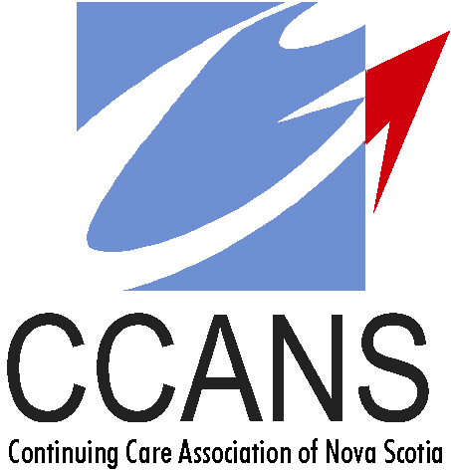
2023 CONFERENCE REGISTRATION FORM
JUNE 14th, 15th, 16th OAK ISLAND RESORT
CONFERENCE REGISTRATION DEADLINE IS JUNE 1st, 2023

Please use one of the following for the REGISTRATION FORM
Email: della_boyle@hotmail.com or FAX: 902-893-8094 or Mail: Della Boyle c/o Townsview Estates, PO Box 1825 Truro, NS B2N 5Z5. Inquires call 902-890-5513
Please use one of the following for REGISTRATION PAYMENT
E-TRANSFERS: della_boyle@hotmail.com or MAILED CHEQUE PAYABLE TO: CCANS (Send to mailing address above. Please include registration form)
CCANS VOTING MEMBER MUST BE CURRENT IN THEIR DUES AND ATTEND THE AGM, ON JUNE 15th, TO RECEIVE FREE REGISTRATION.
Registration Information
Conference Fee Includes: Entertainment, banquet, meals, nutrition breaks and access to conference presentations and activities.
- Please note that breakfast is not included with the registration.
Organization/Facility: Contact Name: Phone:
Email: Mailing Address:
Voting Member (Free)
2nd Attendee Name
3rd Attendee Name
4th Attendee Name

Members are welcome to have a guest join them at Oak Island to attend meals & entertainment. See price matrix below for guest meals & entertainment only.
Name Position Guest of Attendee (if applicable)
*If sending more than 4 participants, please use multiple forms

Please list any dietary restrictions below:

 | NUMBER | FEES | TOTAL
CCANS Voting Member | 1 | FREE | FREE
2nd, 3rd & 4th Attendee Members |  | $199.00 | $
Non-Member- Full Registration |  | $249.00 | $
 | Registration Total |  | $
Additional Guests – Meals & Entertainment Only
Guest – June 14th Social |  | $40.00 | $
Guest – June 15th Lunch |  | $35.00 | $
Guest – June 15th Banquet & Entertainment |  | $85.00 | $
 | Guest Total |  | $
 | Grand Total |  | $

___________________________________

___________________________________

___________________________________

___________________________________

